 | TOGETHER  Quarterly Newsletter  August, September, October 2026

Minister’s Letter

A Rather Warm Summer

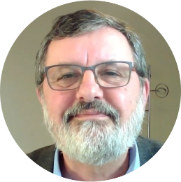
As I write this, much of the UK has experienced its third heatwave of the summer. We still might have more. For many people, a spell of sunshine is something to enjoy. Gardens flourish, children play outdoors, and parks and beaches fill with families. Yet this year, as in recent years, these prolonged periods of intense heat also bring concern. We hear of dried-up rivers, stressed crops, increased risk of wildfires, and warnings for older people and those with health conditions to stay cool and hydrated.

No single heatwave can be blamed entirely on climate change, but scientists continue to tell us that a warming climate makes such extreme weather more frequent and more intense. Around the world, people are living with the consequences: floods, droughts, rising sea levels and changing weather patterns that threaten homes, livelihoods and food supplies.

For Christians, climate change is not simply an environmental issue. It is also a spiritual and moral one. The opening chapters of Genesis remind us that the earth belongs to God. We are not its owners but its caretakers. In Genesis 2:15 we read: "The Lord God took the man and put him in the garden of Eden to till it and keep it." Those two simple words, till and keep, speak of both using creation wisely and protecting it faithfully.

The Psalms also remind us that "The earth is the Lord's and all that is in it" (Psalm 24:1). If the world belongs to God, then caring for it becomes an act of worship. We honour the Creator by treating creation with respect rather than carelessness.

Sometimes the scale of the climate crisis can feel overwhelming. It is easy to wonder whether anything we do could possibly make a difference. Yet the Christian life has never been about waiting until we can do everything before doing anything. Jesus spoke often about faithfulness in small things. Small acts, multiplied across many lives, become significant.

Perhaps that means reducing waste, thinking more carefully about our energy use, planting flowers for pollinators, supporting conservation projects, or encouraging those in authority to make wise and courageous decisions. As a church, it also means praying for our world and remembering that the poorest communities are often those who suffer most from environmental change despite contributing least to it.

Hope is central to our faith. Christians are not people of despair but of resurrection. We believe in the God who is making "all things new" (Revelation 21:5). That hope does not excuse us from responsibility; rather, it inspires us to live today as faithful stewards of God's wonderful creation.

May this summer's unusual heat remind us not only of the challenges before us but also of our calling to cherish, protect and give thanks for the beautiful world that God has entrusted to our care.
Blessings, David

News


We held our Spring Mini-Concert and Afternoon Tea on Saturday 9th May in Saxmundham Chapel. We were greatly encouraged by the attendance with around twenty folk joining the audience.

As they say, the programme did exactly what it says on the tin – a selection of songs from a wide range of genre including religious music, pop songs and a jaunty sing-a-long section. The usual tasty tea followed with a few new features such as an apple crumble cake. Donations totalled £120 - thankyou to everyone who came along and supported the event.

Our next concert will be in October – see the events section below for details.

Film Lunch


For our film lunch on Saturday 6th June, we enjoyed a French themed lunch and watched the Ealing Comedy Classic – Passport to Pimlico. Starring Stanley Holloway, Hermione Baddeley, Margaret Rutherford and Paul Dupois, it tells the story of a community who discover their links to France and declare independence. After much trouble they are reconciled with the UK and things return to normal but the adventures on the way proved highly entertaining. Our next Film Lunch will be in September, see the events section for details.

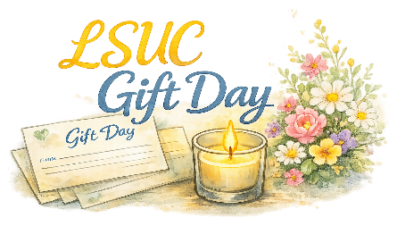
On Sunday 28th June we held our annual church gift day with worship led by Revd David. We would like to say a huge thankyou to everyone who contributed to the work and mission of the church. We are delighted to report that a total of £540 was given – what a blessing.

Planning for the Future

On Wednesday 10th June Revd David and Revd Adam spent several hours in Saxmundham and Leiston reflecting on the LSUC mission action plan and prayerfully discussing some of the different strands of the life and work of the church. There are many important things, including some challenging and inspiring opportunities for the elders and members to consider.

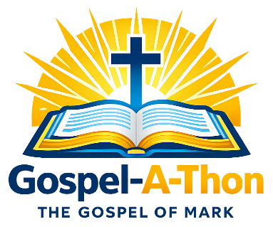
The Leiston and Saxmundham Christians Together “Gospel-A-Thon” took place in Church Square, Leiston, on Saturday 1st August from 10:30 to around 12:45. During the morning folk from the local churches read through each of the chapters of the Gospel according to Mark.
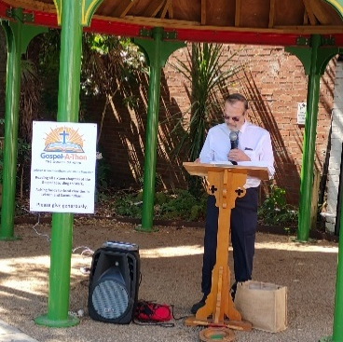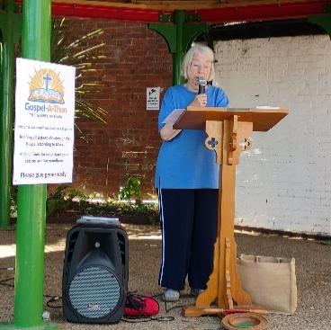

Mark is the shortest of the Gospels with just sixteen chapters. It is also the earliest of the accounts. It was a blessing to hear the whole text read out, interspersed with some worship songs led by Revd Adam and Gillian.

We were able to raise a small amount from donations, £60, which was then given to the East Anglia Children’s Hospice in support of their work. Thank you to everyone who contributed to the day and contributed towards the charity.

Welcoming Jo Moreira

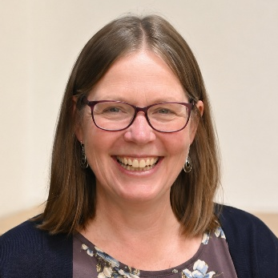
From September 2026 to May 2027 we will be welcoming Jo Moreira, trainee minister from Westminster College - Cambridge, for part of her final year “Living Ministries” placement. Based in Lowestoft Jo will be working with Southwold URC and LSUC and will be leading our service about once a month and joining in some of our other activities and events. Jo has already been introduced to some folk as she has attended a couple of our “Start The Week” events.

As part of the preparation for Jo’s placement, we need to make the following information available.

“We are pleased to welcome Jo Moreira, a trainee minister from Westminster College (Cambridge), who will be on placement with us at Leiston and Saxmundham United Church (LSUC). Jo will be required to reflect on her experiences at LSUC as part of her formation during the college-based programme. Written case studies will only be seen by the college tutor and Trainees on The Living Ministry Programme. All names and identifying details will be changed. If you have concerns about this, please contact Revd Dan Pratt – Director of Pastoral Studies (Westminster College), email djp208@westminster.cam.ac.uk
or call 01233 330623. Alternatively speak to Revd David or Revd Adam.

In Loving Memory


On Friday 10th July a goodly number of family and friends gathered at Saxmundham Chapel to celebrate the life of Gloria Newson, and say a very fond farewell to a much loved elder and member of our church family. The service was led by Revd Adam.

Gloria was born on Tuesday 7 July 1936, to her parents Ethel and Robert Capps, a little sister to her brother Alan, who was some ten years her senior. During the service we reflected on her life from birth to her passing on Friday 12th June 2026, just a few weeks shy of her 90th birthday. Gloria was a wonderful example of love and faith lived out in family, church and community.

Gloria can be seen in the following picture, sitting next to her son Ian, with daughter Anna a little further along the pew.

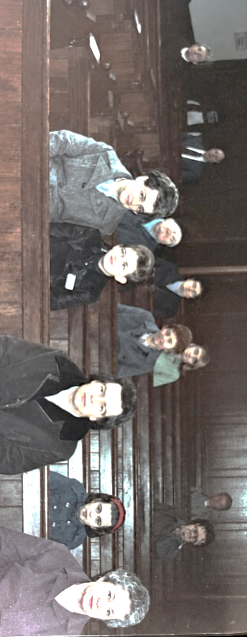

Gloria was part of the team that led the Sunday School for many years and a number of folk (including her own children Ian and Anna) present at the service remembered their time in Sunday School with great affection. She was ordained as an elder in the URC in 1986. She continued as an elder for forty years. Anna was able to locate her certificate:

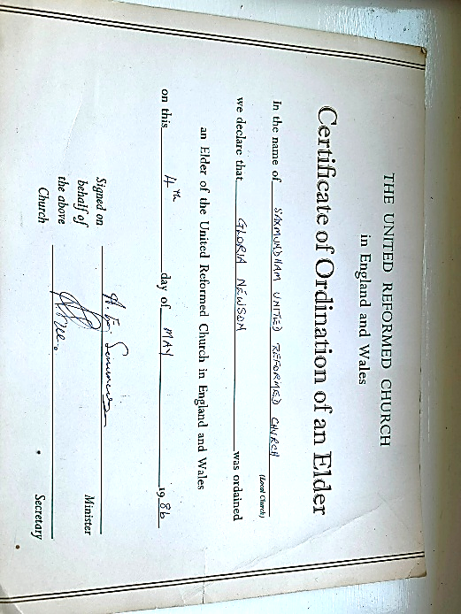

Following the service Gloria was laid to rest in the Saxmundham Chapel church yard. Her beloved husband Michael’s ashes were laid with her. Afterwards folk gathered in the church hall (school room) for tea and further time to remember and celebrate Gloria’s life.

Events


Forthcoming Worship

Please see, and make sure you keep, the final page of this newsletter. This gives full details of the services, including the venue and leaders, for August to October. Please note that we have now transitioned to holding just one service each month at Saxmundham Chapel and the others at Leiston Church (unless otherwise indicated).


The forthcoming dates for Start the week, at Saxmundham Chapel, beginning at 10:00am, are as follows: 24th August, 28th September and 26th October. Pop the dates in your diary and we look forward to seeing you. All are welcome.



Every Friday and Saturday
10:00am – 12:00pm
LSUC Leiston Church


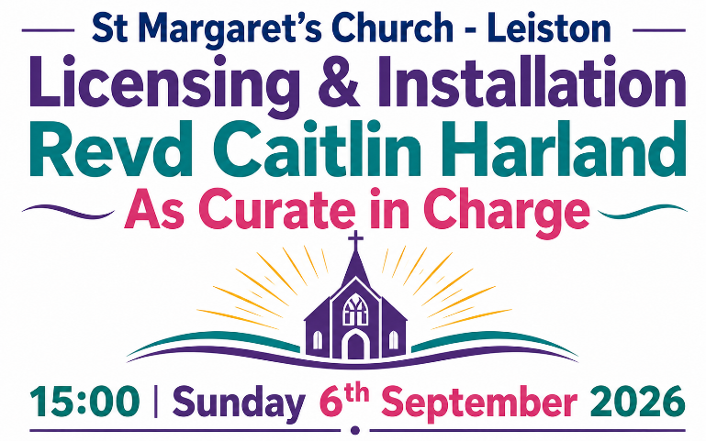

Having said farewell to Revd Richard Finch, on his retirement in June, we are pleased to be able to share the news that St Margaret’s will have a new minister from September. Revd Caitlin Harland will be joining the parish as Curate in Charge. There is a special service for her licensing and installation as detailed above. We pray for Caitlin as she begins this new role and for all our friends at St Margaret’s.


14:00 Thursday
24th September 2026
If you would like to join us, please speak to Marion Sillett who will also give details of the cost. Numbers limited so don't leave it too long.
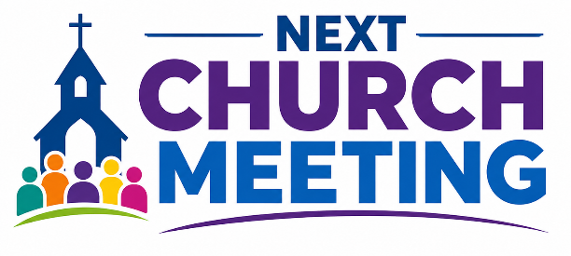
Our next church meeting will be held on Tuesday 29th September at 10:30am at Leiston Church. Do come along and find out more. Whilst only church members are able to vote we welcome all our friends to join in the conversation and bring wisdom to our discussions.



Special Worship Services

United Worship

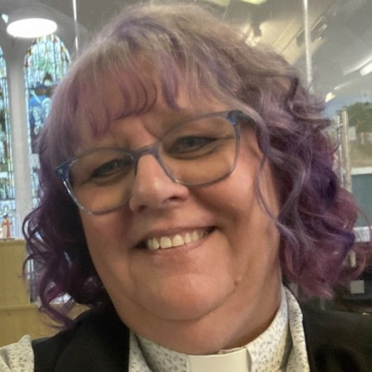
On Sunday 30th August we have our next United service with the folk from Kelsale, Peasenhall and Knodishall Methodist Churches. The service will, this time, be held at LSUC Leiston at 10:30am. The service will be lead by the Superintendent Minister of the Ipswich Methodist Circuit – Revd Vivienne Smith. Some of us were present when she lead the united service at Peasenhall. We look forward to welcoming her to Leiston.

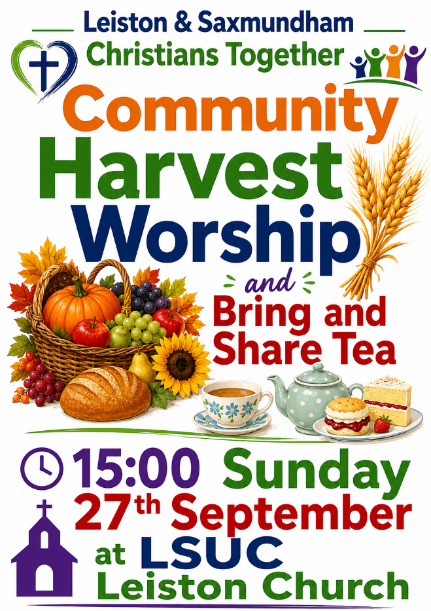

Please note that this service will be our main act of worship for LSUC on 27th September. The service begins at 3:00pm, slightly later than our usual afternoon service time. We would also welcome contributions to the bring and share tea which will follow.

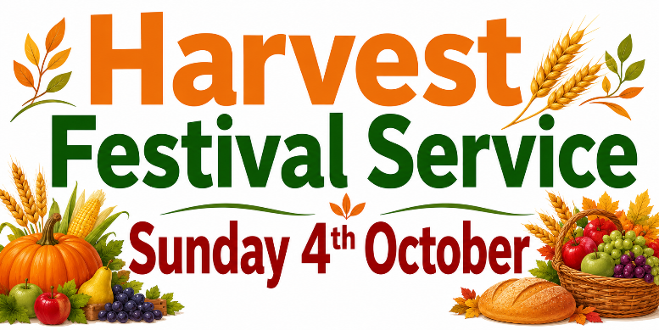

We have our own Harvest Festival Service at 10:30am on Sunday 4th October. The service will be led by Sue Liddell and David Sillett. We welcome gifts of canned, dried and shelf-stable produce or contributions of money towards the Food Bank.
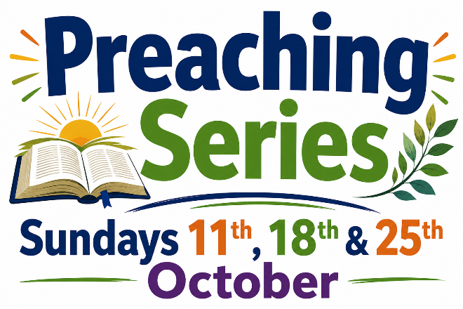

In October, as part of the plan introduced across the pastorate, we will have three services in a row, with the messages at each linked to a common theme. Two of the services will be led by Revd David and one by trainee minister Jo Moreira. Do try and get along to hear all three in the series if you are able.

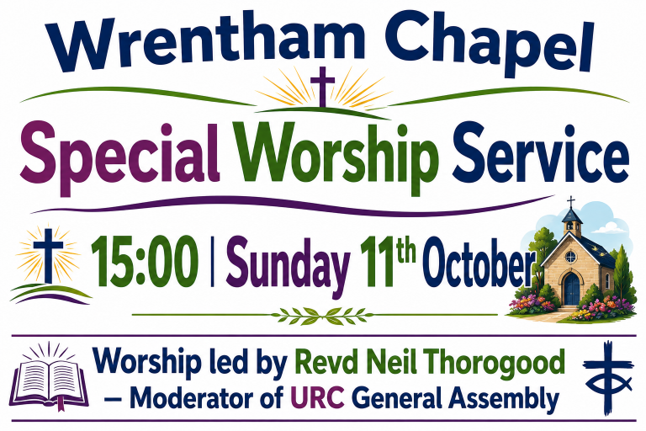

On Sunday 11th October at 3:00pm our friends at Wrentham Chapel are hosting a service of worship led by the Moderator of the URC General Assembly for 2026-2027, the Revd Neil Thorogood. Neil was formerly the Principal of Westminster College, Cambridge before returning to pastoral ministry as Minister of Thornbury and Trinity-Henleaze URCs in South Western Synod. Do please come along and join in this special time of worship.
The next edition of the “LSUC Together” Quarterly Newsletter will be available in November. The Pastorate “Connect” Magazine will be available in September.

Worship Arrangements
August to October 2026

August 2026

Sunday 9th August
10:30 @ Leiston
Led by the Elders
Sunday Worship (Hybrid)
Message recorded by Revd Adam Earle

Sunday 16th August
10:45 @ Saxmundham
Led by the Elders
Service of Praise & Reflection

Sunday 23rd August
14:00 @ Leiston
Led by Revd Adam Earle
Afternoon Worship

Sunday 30th August
10:30 @ Leiston
Led by Revd Vivienne Smith
United Service

September 2026

Sunday 6th September
10:45 @ Saxmundham
Led by Sue Liddell
Sunday Worship with Communion

Sunday 13th September
10:30 @ Leiston
Led by the Elders
Sunday Worship (Hybrid)
Message recorded by Revd David Rees

Sunday 20th September
10:30 @ Leiston
Led by the Elders
Service of Praise & Reflection

Sunday 27th September
15:00 @ Leiston
Led by Revd David Rees
Leiston & Saxmundham
Christians Together
Community Harvest Service
and Bring & Share Tea

October 2026

Sunday 4th October
10:30 @ Leiston
Led by Sue Liddell & David Sillett
Harvest Festival Service

Sunday 11th October
10:45 @ Saxmundham
Led by Revd David Rees
Sunday Worship (Block Series 1)

Sunday 18th October
10:30 @ Leiston
Led by Jo Moreira
Sunday Worship (Block Series 2)

Sunday 25th October
14:00 @ Leiston
Led by Revd David Rees
Sunday Worship (Block Series 3)



